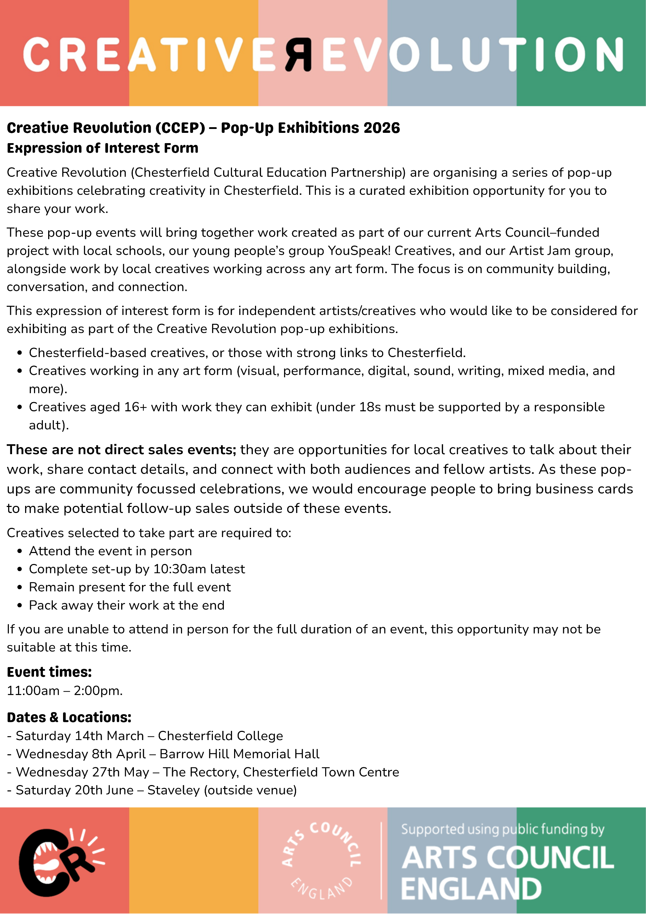
Artist / Creative Details:

Name:

Email Address:

Phone Number:

- Are you based in Chesterfield or do you have strong links to Chesterfield?
Please briefly explain:

- What is your main art form or creative practice?

- Please briefly describe your creative practice and work (100–200 words) or attach a 1 minute film:

- Please describe the work you would like to exhibit:

- How would the work be displayed? (wall-based, table-based, digital, etc.):

- How much space do you think you will need?

- What equipment or support would you need?

- Are you able to provide everything required to display your work?
Yes / No / Partially (please explain):

- Does your work require additional installation or set-up time?

- Please confirm you can attend in person, complete set-up by 10:30am, stay 11:00am–2:00pm, and pack away:

- Which event dates are you available for?

- Are you comfortable engaging with visitors and talking about your work?

- Do you follow Creative Revolution Chesterfield on social media?
Facebook – www.facebook.com/profile.php?id=61580529930548
Instagram - https://www.instagram.com/creativerevolutionchesterfield/

- Have you attended Artist Jam sessions?
www.eventbrite.co.uk/o/creative-revolution-ccep-112722052381

- Do you use any of any of the following?
Artists Jam Padlet -padlet.com/KateCCEP/ArtistsJam
Creatives WhatsApp - chat.whatsapp.com/J1XtLXidengHNi9gBZNgGu
Creative Revolution Mailing List - ccep.org.uk/ (scroll to bottom)

- Would you be willing to help promote the event through your own channels? Please provide your social media handles:

- Do you give permission for photos or video to be taken during the event?

- Are you happy for images of your work to be used in future promotion?

- Please attach or provide links to up to 3 images, videos, or samples of your work:

- Please attach or link to one photo of yourself for social media promotion prior to the event:

- Do you have any access or support needs we should be aware of?

- Is there anything else you would like us to know?

Please email your completed form to hello@ccep.org.uk. Email subject line: Pop-Up Expression of Interest

By submitting this form, you confirm that you understand the event timings and attendance requirements. We will be in touch to confirm and with more details as soon as possible.

If you have any questions, please email kate@ccep.org.uk

